A

**MINI PROJECT REPORTON**

**ON**

“Note APP”

**SUBMITTED TO**

SAVITRIBAI PHULE PUNE UNIVERSITY, PUNE

**FOR THE PARTIAL FULLFILLMENT OF THE DEGREE OF MASTER OF COMPUTER APPLICATION (MCA) SUBMITTED BY**

**Dhorde Aishwarya Pravin**



PIRENS INSTITUTE OF BUSINESS MANAGEMENT AND ADMINISTRATION (IBMA)

**LONI (BK), TAL- RAHATA, DIST.- AHMEDNAGAR.**

**SAVITRIBAI PHULE PUNE UNIVERSITY 2022-23.**

**1**



##### CERTIFICATE

This to certify that the

**Mini Project Report** entitles

“ Notes App Project**”**

SUBMITTED BY

**Dhorde Aishwarya Pravin**

Seat Number –23247

Is a bonafide student of this institute and the work has been carried out by him under the supervision of **Prof. R.V.Kotkar** and it is approved for the partial fulfillment of the requirement of Savitribai Phule Pune University, for the award of the degree of Master Of Computer Application (MCA).

Prof. R.V.Kotkar Prof. Y.S. Jorwekar

(Internal Guide) (Academic Coordinator (MCA)

Dr.A.R. V. NJaswal

(Director,IBMA)

2



**SAVITRIBAI PHULE PUNE UNIVERSITY, PUNE**

##### CERTIFICATE

This to certify that Dhorde Aishwarya Pravin

**Seat Number-23247**

Student of Second Year of Master of Computer Application (MCA) was examined in **Mini Project Report** entitled

“NeutriNotes App”

On - / /2023

**At**

**PIRENS INSTITUTE OF BUSINESS MANAGEMENT AND ADMINISTRATION,(IBMA)**

**LONI(BK), TAL- RAHATA, DIST- AHMEDNAGAR.**

**(Internal Examiner) (External Examiner)**

3

**CERTIFICATE BY GUIDE**

This is to certify that **Dhorde Aishwarya Pravin** has completed the Mini Project work under my guidance and supervision that I have verified the work for documentation, problem statement and result presented in the project work.

**Place:** Loni **Prof. R.V.Kotkar**

**Date:** / /2023

4

### Index

|  |  |  |
| --- | --- | --- |
| **SR.**  **NO** | **CHAPTER NAME** | **PAGE**  **NO** |
| **1.** | **INTRODUCTION** | 06 |
|  | 1.1 INTRODUCTION TO PROJECT | 07 |
|  | 1.2 EXISTING SYSTEM | 08 |
|  | 1.3 NEED OF THE SYSTEM | 08 |
|  | 1.4 HARDWARE AND SOFTWARE SPECIFICATIONS | 09 |
|  |  |  |
| **2.** | **PROPOSED SYSTEM** | 10 |
|  | 2.1 PROPOSED SYSTEM | 11 |
|  | 2.2 OBJECTIVE OF THE SYSTEM | 11 |
|  | 2.3 FEASIBILITY STUDY | 11 |
|  | 2.3.1 TECHNICAL FEASIBILITY | 12 |
|  | 2.3.2 OPERATIONAL FEASIBILTY | 13 |
|  | 2.3.3 ECONOMICAL FEASIBILTY | 14 |
|  |  |  |
| **3.** | **SYSTEM ANALYSIS AND DESIGN** | 15 |
|  | 3.1 USECASE DIAGRAMS | 15 |
|  | 3.2 ACTIVITY DIAGRAMS | 16 |
|  | 3.3 COMEPONET DIAGRAMS | 17 |
|  | 3.4 STATE CHART DIAGRAMS | 18 |
|  | 3.5 MODULE SPECIFICATIONS | 19 |
|  | 3.6 SYSTEM TESTING AND IMPLEMENTATION | 20-22 |
|  |  |  |
| **4.** | **ADVANTAGES AND DISADVANTAGES** | 23 |
|  |  |  |
| **5.** | **CONCLUSION** | 24 |
|  |  |  |
| **6.** | **BIBLIOGRAPHY** | 25 |
|  |  |  |
| **7.** | **SCREENSHOTS** | 26-34 |
|  |  |  |
| **8.** | **SAMPLE PROGRAM CODE** | 35-36 |

5

Chapter No 1

**INTRODUCTION**

* 1. Introduction to System
  2. Existing System
  3. Need for the System
  4. System Requirement Specifications

6

**INTRODUCTION**

People write down notes to free their minds.

They need to keep ideas, tasks or other information in order to reach their work goals

.

People can write down their notes on paper or post-it sticky notes.

When they require notes to be saved in a digital form, computers and mobile devices can be used.

There are many applications usable for creating notes: simple programs such as Notepad, generic word processors (for example Microsoft Word) or specialized software for managing notes and documents such as Evernote.

Note taking applications offer different features for writing and organizing notes, support different platforms etc.

Because that users do not have the same note taking styles, they require different of features for work with notes and thus they feel comfortable with different applications.

This thesis is focused on specialized note taking applications.

7

**Existing System**

Make sure you have updated neutriNote to v4.2.2 or above.

With the use of a file manager app, temporarily rename the mirror folder to something other than mirror.

Make sure neutrinote_settings_data.txt and ~neutrinote_app_data.txt are not empty.

Under Settings, disable Auto Backup.

Tap Import Files under the main menu. Choose the renamed folder in Step 2.

Wait for the import to complete.

Upon completion, click Restore App Data from the side navigation menu.

Revert the name of the folder back to mirror.

Under Settings, enable Auto Backup.

**NEED OF THE SYSTEM**

These notes can serve as reminders to complete assignments or as a pedagogical tool to elaborate on in-class lectures, create discussion questions, and more.

Title: Before starting note-making, go through the source material twice or thrice to have a good understanding of the topic.

Content: While writing the body, focus on the content you are adding in.

Readability: Include subheadings, bullet points, numberings to make it good to read.

8

### SYSTEM REQUIREMENT SPECIFICATIONS

**Hardware Requirements:**

1. **Laptop -**
   * + Processor: Intel(R) Core(TM) i3-4500U CPU @ 1.80GHz 2.40 GHz
     + RAM: 8.00 GB
     + Hard Disk storage: 1TB
     + Operating System: Windows 10 Home & Student Edition
2. **Smartphone device -**
   * + Processor make: Qualcomm Snapdragon 652 (MSM8976) –
     + RAM: 4.00 GB
     + Phone Storage: 64 GB
     + Operating System: Android version 5.1.1 (Lollipop)

**Software Requirements:**

* + - **Operating System :** Windows

Android Studio

* + - **Front-End :** Java
    - **Back-End :** Firebas**e**

9

Chapter 2

**PROPOSED SYSTEM**

* 1. Proposed System
  2. Objective of the System
  3. Feasibility Study

10

##### 2.1 PROPOSED SYSTEM

Notes is the best place to jot down quick thoughts or to save longer notes filled with checklists, images, web links, scanned documents, handwritten notes, or sketches.

And with iCloud, it's easy to keep all your devices in sync, so you'll always have your notes with you.

**2.2 OBJECTIVE OF THE SYSTEM**

• No reach limitations, it provides a user-friendly GUI which results in retaining of users.

• Media attachment support and inbuilt scanner to scan notes.

• Flexibility for users to generate various files of notes such as .png, .pdf, .txt

• Inbuilt Passcode and biometric security.

• Lightweight SQLite database.

### 2.3FEASIBILITY STUDY

* + - Whatever we think need not be feasible. It is wise to think about the feasibility of any problem we undertake.
    - Feasibility is the study of impact, which happens in the organization by the development of a system. The impact can be either positive or negative.
    - When the positives nominate the negatives, then the system is considered feasible.
    - Here the feasibility study can be performed in two ways such as technical feasibility, Operational Feasibility and Economical Feasibility.

11

* + 1. **TECHNICAL FEASIBILITY**

The technical issue usually raised during the feasibility stage of the investigation includes the following:

* + - * Does the necessary technology exist to do what is suggested?
      * Do the proposed equipment’s have the technical capacity to hold the data required to use the new system?
      * Will the proposed system provide adequate response to inquiries, regardless of the number or location of users?
      * Can the system be upgraded if developed?
      * Are their technical guarantees of accuracy, reliability, ease of access and data security?

Earlier no system existed to cater to the needs of ‘Secure Infrastructure Implementation System’. Thus, it provides an easy access to the users. The database’s purpose is to create, establish and maintain a workflow among various entities in order to facilitate all concerned users in their various capacities or roles. Permission to the users would be granted based on the roles specified.

Therefore, it provides the technical guarantee of accuracy, reliability and security. The work for the project is done with the current equipment and existing software technology.

Necessary bandwidth exists for providing fast feedback to the users irrespective of the number of users using the system

12

* + 1. **OPERATIONAL FEASIBILITY**

Proposed projects are beneficial only if they can be turned out into information system. That will meet the organization’s operating requirements. Operational feasibility aspects of the project are to be taken as an important part of the project implementation. Some of the important issues raised are to test the operational feasibility of a project includes the following: -

* + - * Is there sufficient support for the management from the users?
      * Will the system be used and work properly if it is being developed and implemented?
      * Will there be any resistance from the user that will undermine the possible application benefits?

This system is targeted to be in accordance with the above- mentioned issues. Beforehand, the management issues and user requirements have been taken into consideration. So, there is no question of resistance from the users that can undermine the possible application benefits.

The well-planned design would ensure the optimal utilization of the computer resources and would help in the improvement of performance status.

13

* + 1. **ECONOMICAL FEASIBILTY**

A system can be developed technically and that will be used if installed must still be a good investment for the organization. In the economic feasibility, the development cost in creating the system is evaluated against the ultimate benefit derived from the new systems.

Financial benefits must equal or exceed the costs.

The system is economically feasible. It does not require any addition hardware or software.

Since the interface for this system is developed using the existing resources and technologies available at computer, there is nominal expenditure and economic feasibility for certain.

14

Chapter 3

# SYSTEM ANALYSIS AND DESIGN

# 1.Use case Diagram for Notes App

System boundary

**user system**

In this use case digram user and system can intract with each other as show in below.

15

2.Activity Diagrams for Nots app

user

Launch app

Home screen

Select read notes

Read note displayed

Exit or home screen

View read note

Exit app

Home screen

In this activity diagram to show flow of system.

16

**3.Component Diagrams for nots app**

Notes app

Create note

Title add

Function content

Content add

Save file

## This note app show all component with ths help of component digram.

## 17

## 4. State chart diagram for Notes App

Start

Home page

Create text file

Create note

Tititle add

Add title

Add content

Write content

Various function

Content function

**End**

In state chart diagram shows steps of user to use this note app.

18

### MODULE SPECIFICATIONS

#### Neutrinotes Application has following three modules.

1.user

2.system

### SYSTEM TESTING AND IMPLEMENTATION

#### 3.6.1 INTRODUCTION

Software testing is a critical element of software quality assurance and represents the ultimate review of specification, design and coding. In fact, testing is the one step in the software engineering process that could be viewed as destructive rather than constructive.

A strategy for software testing integrates software test case design methods into a well-planned series of steps that result in the successful construction of software. Testing is the set of activities that can be planned in advance and conducted systematically. The underlying motivation of program testing is to affirm software quality with methods that can economically and effectively apply to both strategic to both large and small-scale system

19

#### .2 STRATEGIC APPROACH TO SOFTWARE TESTING

The software engineering process can be viewed as a spiral. Initially system engineering defines the role of software and leads to software requirement analysis where the information domain, functions, behavior, performance, constraints and validation criteria for software are established. Moving inward along the spiral, we come to design and finally to coding. To develop computer software, we spiral in along streamlines that decrease the level of abstraction on each turn.

A strategy for software testing may also be viewed in the context of the spiral. Unit testing begins at the vertex of the spiral and concentrates on each unit of the software as implemented in source code. Testing progress by moving outward along the spiral to integration testing, where the focus is on the design and the construction of the software architecture. Talking another turn on outward on the spiral we encounter validation testing where requirements established as part of software requirements analysis are validated against the software that has been constructed.

Finally, we arrive at system testing, where the software and other system elements are tested as a whole.

20

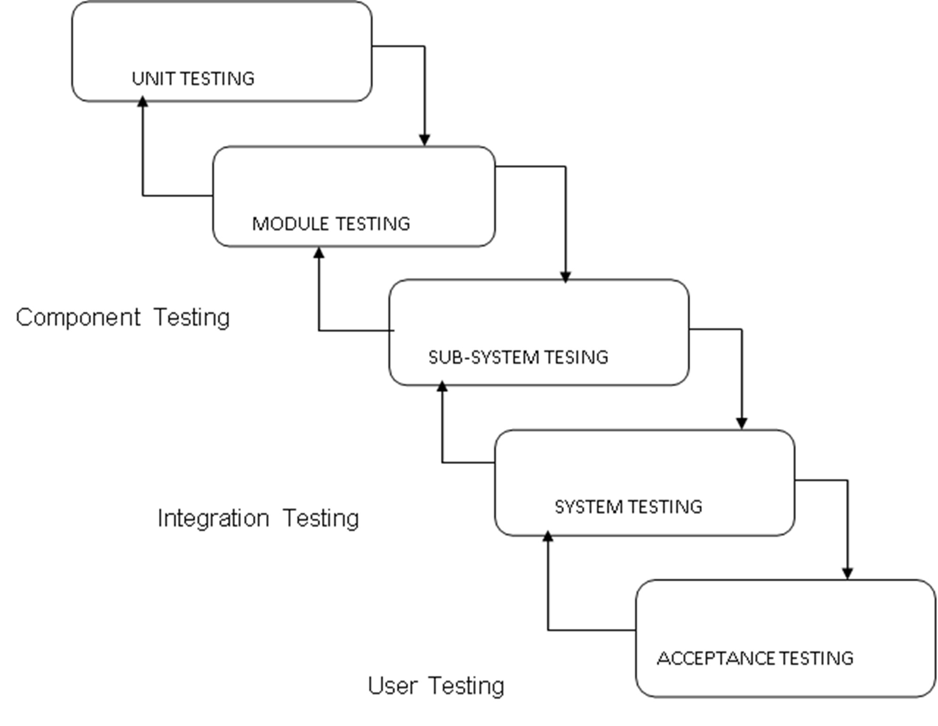

#### UNIT TESTING

Unit testing focuses verification effort on the smallest unit of software design, the

module. The unit testing, we have is white box oriented and some modules the steps are conducted in parallel.

#### WHITE BOX TESTING

This type of testing ensures that

* + All independent paths have been exercised at least once
  + All logical decisions have been exercised on their true and false sides
  + All loops are executed at their boundaries and within their operational bounds
  + All internal data structures have been exercised to assure their validity.

21

#### 

#### **2.CONDITIONAL TESTING**

In this part of the testing each of the conditions were tested to both true and false aspects. And all the resulting paths were tested. So that each path that may be generate on particular condition is traced to uncover any possible errors.

#### **DATA FLOW TESTING**

This type of testing selects the path of the program according to the location of

definition and use of variables. This kind of testing was used only when some

local variable was declared. The definition-use chain method was used in this type

of testing. These were particularly useful in nested statement.

22

Chapter 4

# ADVANTAGES

# 

1. The notes are structured and easy to read
2. It is easy to use
3. Key points are highlighted in a logical way
4. Minimizes editing and review time

**DISADVANTAGES**

1. Is not useful for subjects that include charts and formulas to express themselves like mathematics
2. Is not effective if the proper structure is not followed

23

Chapter 5

# CONCLUSION

From the research we understood that, currently, the popularization of the internet has led to a decline in revenue in the paper industry, but the pen and pencil industry’s revenue has grown in recent years. These conflicting numbers are inconclusive in regards to whether or not students are abandoning paper-based notetaking. Many students are taking advantage of the electronics in the classroom. In conclusion, major benefits of the project are:

24

Chapter 6

# BIBLOGRAPHY

# Android studio refrence book

[www.google.com](http://www.google.com)

[www.youtube.com](http://www.youtube.com)

[www.greeksforgreeks.com](http://www.greeksforgreeks.com)

[www.github.com](http://www.github.com)

25

Chapter 7

# SCREENSHOTS

# C:\Users\Sai\Downloads\WhatsApp Image 2023-01-04 at 7.36.42 PM.jpeg

This is a starting page of note app

26

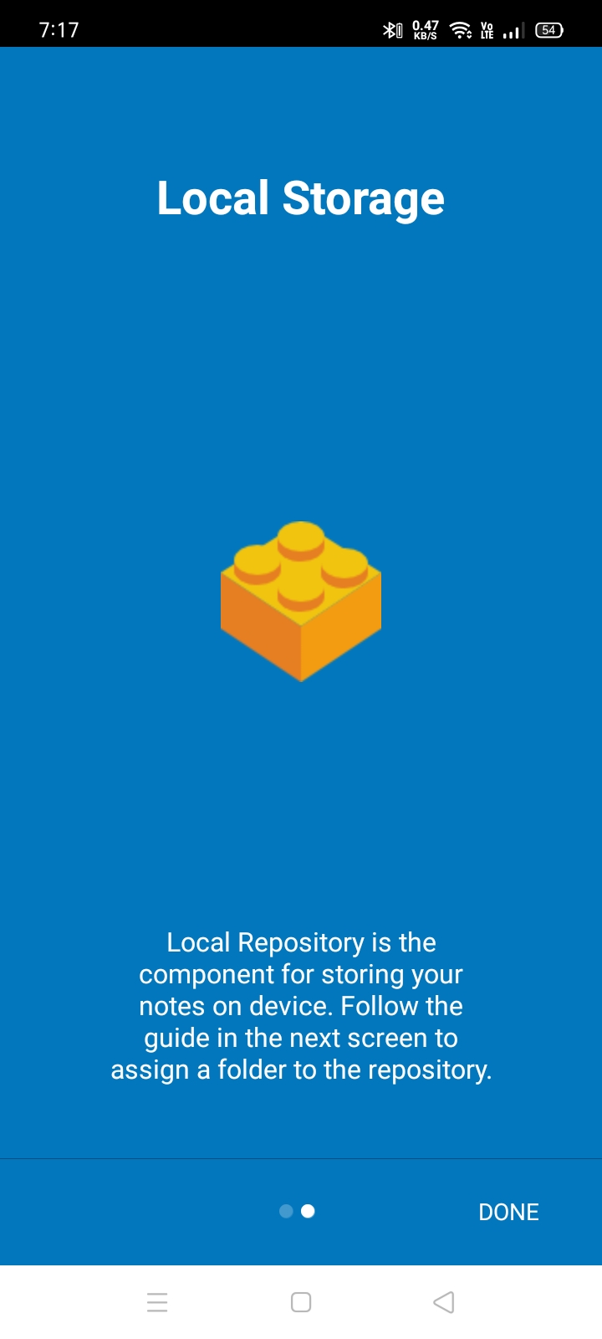

This is a next page of app to show user guide information or app information.

27

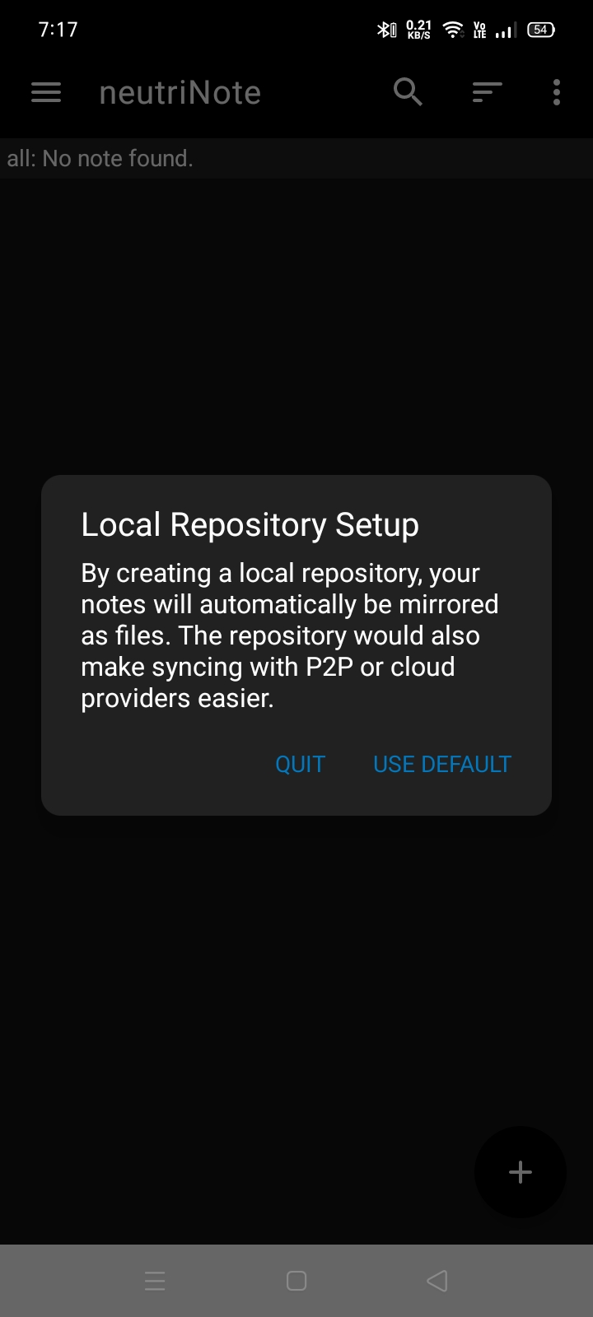

This screen short shows local repository setup.

28

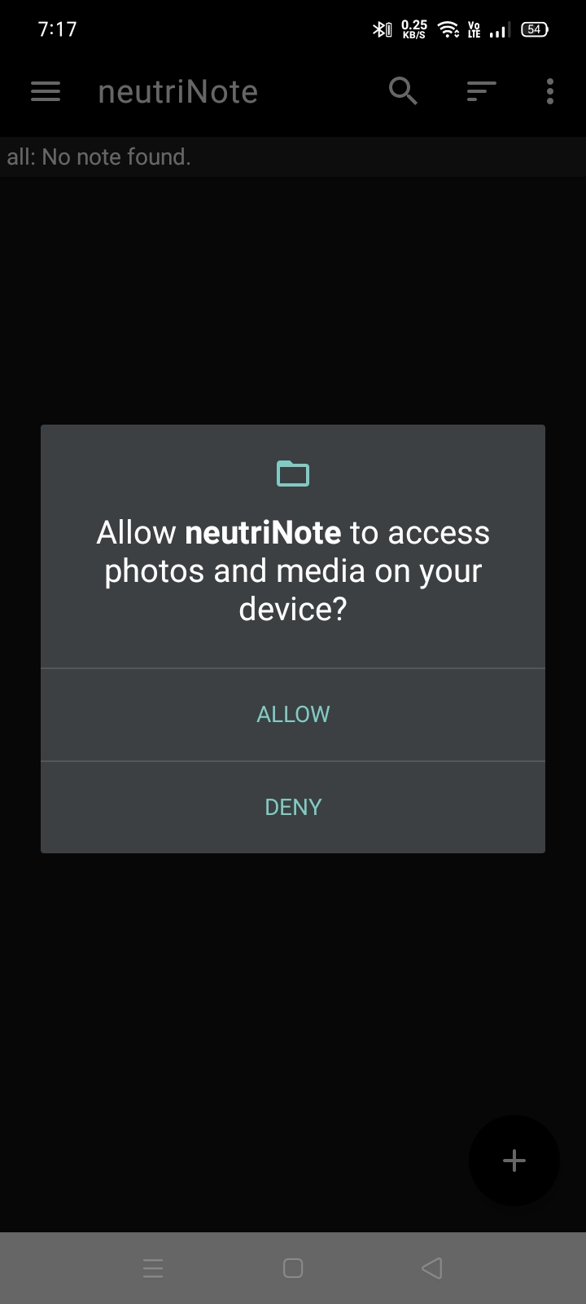

In this screen short app can be allow to permission of axess of file manager.

29

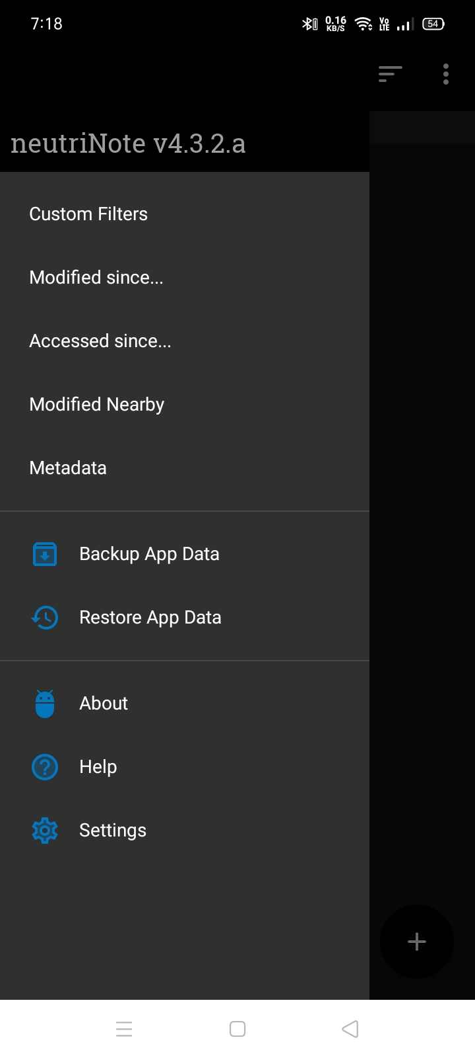

This is a menu bar of note app.

30

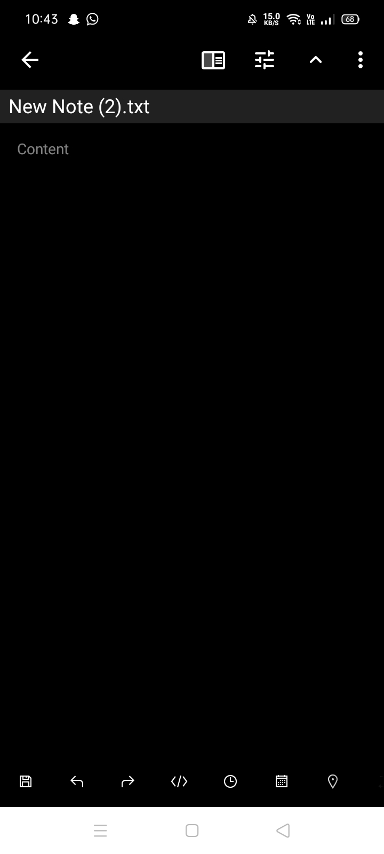

This is a interface of to create a txt.file as shown in screen short.

31

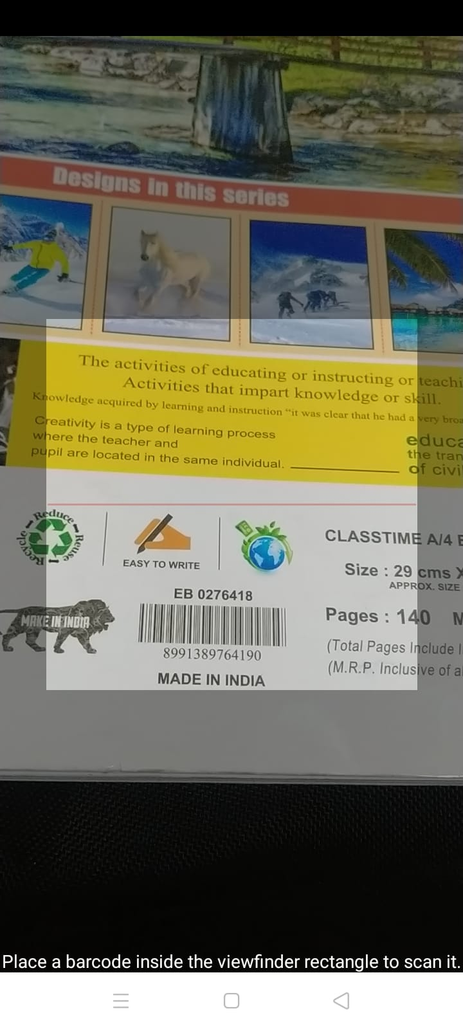

It is also provide to read a barcode and save it.

32

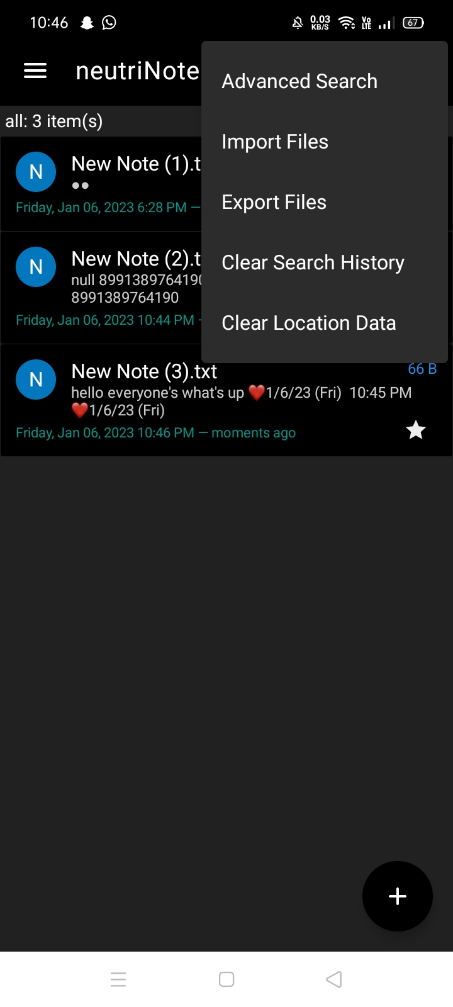

In this screen short show to perform operation to import file, export file and advance search.

33

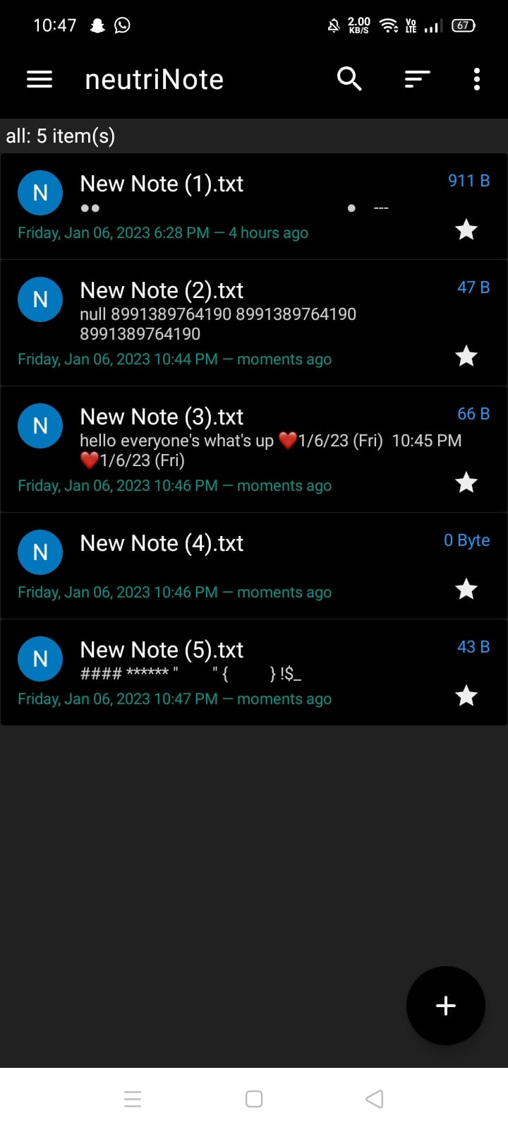

This is a show all total files.

34

# Sample Programme Code

package com.appmindlab.nano;

import android.Manifest;

import android.content.Intent;

import android.content.SharedPreferences;

import android.content.pm.PackageManager

import android.graphics.Color;

import android.os.Build;

import android.os.Bundle;

import android.preference.PreferenceManager;

import androidx.core.content.ContextCompat;

import com.github.paolorotolo.appintro.AppIntro;

import com.github.paolorotolo.appintro.AppIntroFragment;

/**

* Created by saelim on 9/10/2015.

*/

public class IntroActivity extends AppIntro {

private SharedPreferences mSharedPreferences;

private String mLocalRepoPath;

@Override

public void init(Bundle bundle) {

mSharedPreferences = PreferenceManager.getDefaultSharedPreferences(this);

mLocalRepoPath = mSharedPreferences.getString(Const.PREF_LOCAL_REPO_PATH, "");

if (Build.VERSION.SDK_INT >= 23) {

if ((mLocalRepoPath.length() > 0) || (ContextCompat.checkSelfPermission(this, Manifest.permission.READ_EXTERNAL_STORAGE) == PackageManager.PERMISSION_GRANTED))

launchMainActivity();

}

35

else {

if (mLocalRepoPath.length() > 0)

launchMainActivity();

}

// Intro screens

AppIntroFragment slide1 = AppIntroFragment.newInstance(getResources().getString(R.string.intro_getting_started), getResources().getString(R.string.intro_getting_started_desc), R.drawable.intro_notepad, Color.parseColor("#0277BD"));

AppIntroFragment slide2 = AppIntroFragment.newInstance(getResources().getString(R.string.intro_local_repo), getResources().getString(R.string.intro_local_repo_desc), R.drawable.intro_brick, Color.parseColor("#0277BD"));

addSlide(slide1);

addSlide(slide2);

}

@Override

public void onSkipPressed() {

launchMainActivity();

}

@Override

public void onDonePressed() {

launchMainActivity();

}

private void launchMainActivity() {

Intent intent = new Intent(this, MainActivity.class);

intent.addFlags(Intent.FLAG_ACTIVITY_CLEAR_TOP);

startActivity(intent);

finish();

36